**IRCTC SAMPLE**

**-----CREATING DATABASE-------**

MariaDB [(none)]> create database railways;

Query OK, 1 row affected (0.104 sec)

MariaDB [railways]> show databases;

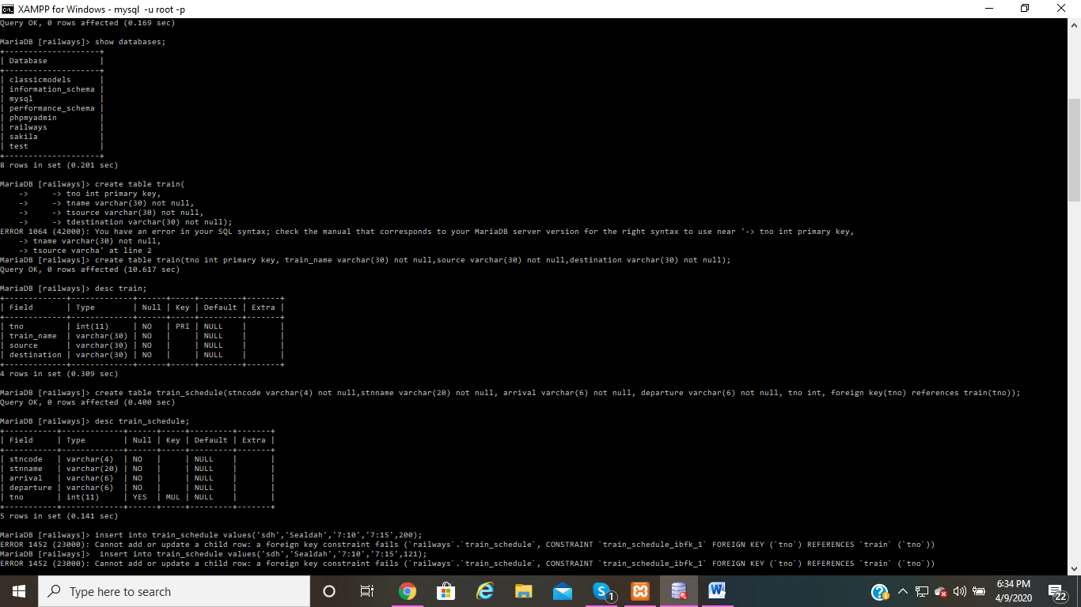+--------------------+

| Database |

+--------------------+

| classicmodels |

| information_schema |

| mysql |

| performance_schema |

| phpmyadmin |

| railways |

| sakila |

| test |

+--------------------+

8 rows in set (0.201 sec)

**-------CREATING TABLE TRAIN---------------**

MariaDB [railways]> create table train(tno int primary key, train_name varchar(30) not null,source varchar(30) not null,destination varchar(30) not null);

Query OK, 0 rows affected (10.617 sec)

MariaDB [railways]> desc train;

+-------------+-------------+------+-----+---------+-------+

| Field | Type | Null | Key | Default | Extra |

+-------------+-------------+------+-----+---------+-------+

| tno | int(11) | NO | PRI | NULL | |

| train_name | varchar(30) | NO | | NULL | |

| source | varchar(30) | NO | | NULL | |

| destination | varchar(30) | NO | | NULL | |

+-------------+-------------+------+-----+---------+-------+

4 rows in set (0.309 sec)

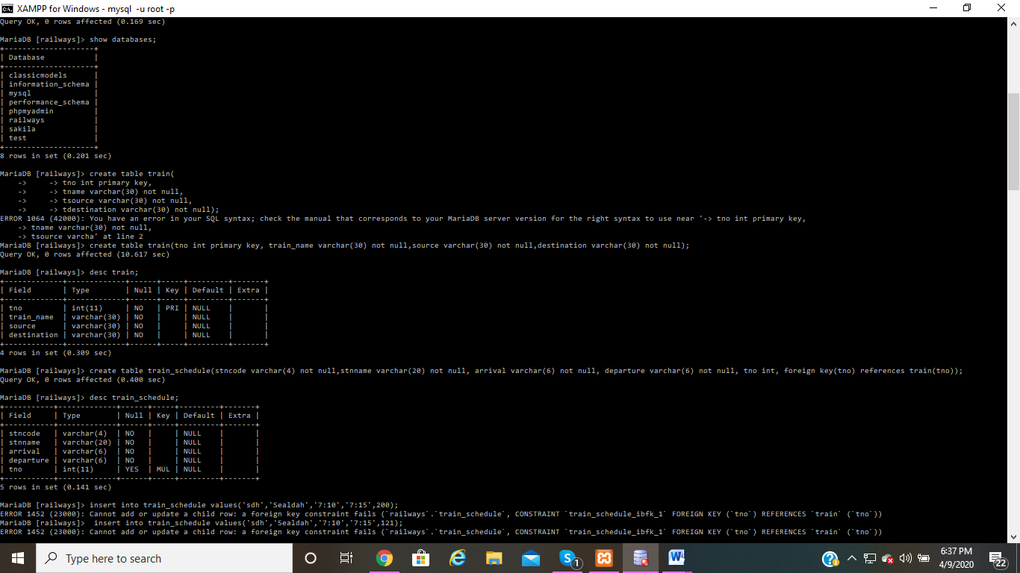

**----------CREATING TABLE TRAIN_SCHEDULE----------------**

MariaDB [railways]> create table train_schedule(stncode varchar(4) not null,stnname varchar(20) not null, arrival varchar(6) not null, departure varchar(6) not null, tno int, foreign key(tno) references train(tno));

Query OK, 0 rows affected (0.400 sec)

MariaDB [railways]> desc train_schedule;

+-----------+-------------+------+-----+---------+-------+

| Field | Type | Null | Key | Default | Extra |

+-----------+-------------+------+-----+---------+-------+

| stncode | varchar(4) | NO | | NULL | |

| stnname | varchar(20) | NO | | NULL | |

| arrival | varchar(6) | NO | | NULL | |

| departure | varchar(6) | NO | | NULL | |

| tno | int(11) | YES | MUL | NULL | |

+-----------+-------------+------+-----+---------+-------+

5 rows in set (0.141 sec)

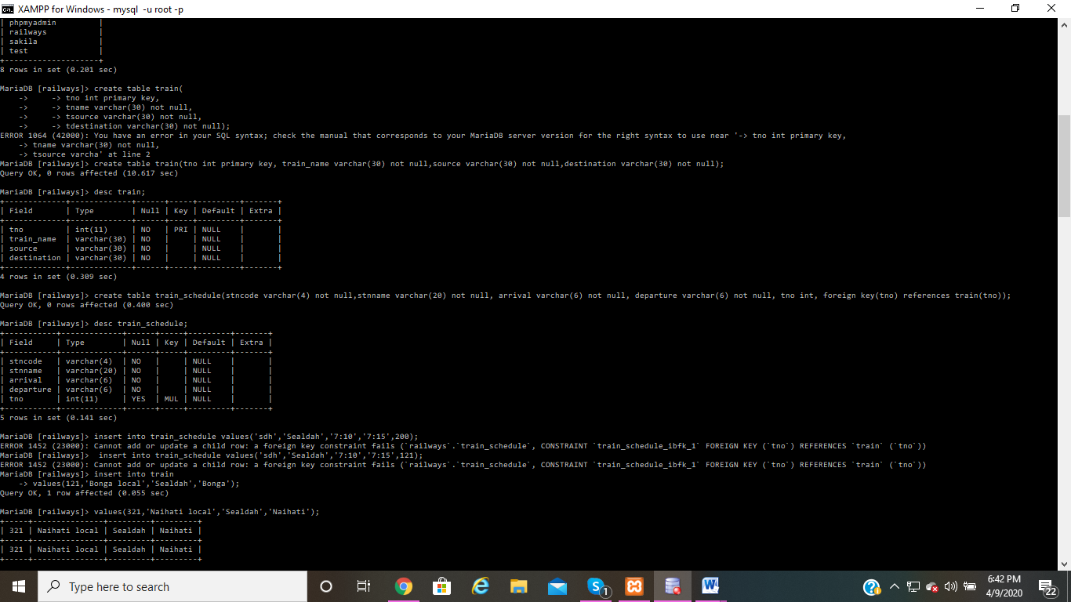

**-----------INSERTING VALUES IN TABLE TRAIN--------------**

MariaDB [railways]> insert into train values(121,'Bonga local','Sealdah','Bonga');

Query OK, 1 row affected (0.055 sec)

MariaDB [railways]> insert into train values(321,'Naihati local','Sealdah','Naihati');

Query OK, 1 row affected (0.032 sec)

MariaDB [railways]> insert into train values(322,'Ranaghat local','Sealdah','Ranaghat');

Query OK, 1 row affected (0.015 sec)

insert into train values(323,'Barasat' local','Seal' at line 1

MariaDB [railways]> insert into train values(323,'Barasat local','Sealdah','Barasat');

Query OK, 1 row affected (0.038 sec)

MariaDB [railways]> insert into train values(324,'Bandel local','Howrah','Bandel');

Query OK, 1 row affected (0.029 sec)

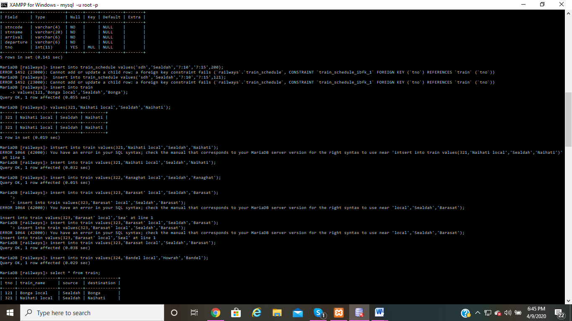

**-----------VIEWING THE DETAILS OF TABLE TRAIN-----------**

MariaDB [railways]> select * from train;

+-----+----------------+---------+-------------+

| tno | train_name | source | destination |

+-----+----------------+---------+-------------+

| 121 | Bonga local | Sealdah | Bonga |

| 321 | Naihati local | Sealdah | Naihati |

| 322 | Ranaghat local | Sealdah | Ranaghat |

| 323 | Barasat local | Sealdah | Barasat |

| 324 | Bandel local | Howrah | Bandel |

+-----+----------------+---------+-------------+

5 rows in set (0.003 sec)

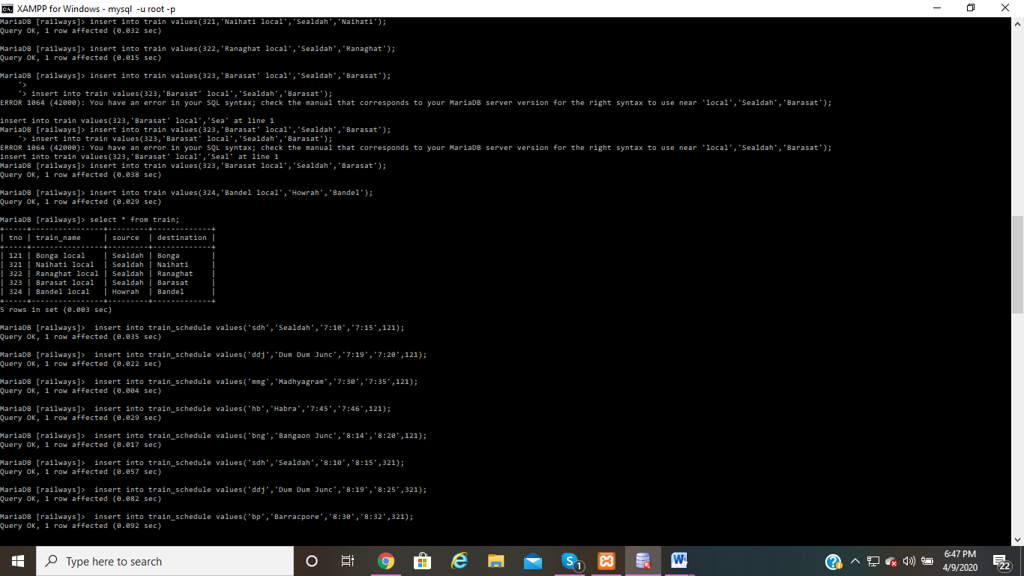

**-------INSERTING VALUES INTO TABLE TRAIN_SCHEDULE-------**

MariaDB [railways]> insert into train_schedule values('sdh','Sealdah','7:10','7:15',121);

Query OK, 1 row affected (0.035 sec)

MariaDB [railways]> insert into train_schedule values('ddj','Dum Dum Junc','7:19','7:20',121);

Query OK, 1 row affected (0.022 sec)

MariaDB [railways]> insert into train_schedule values('mmg','Madhyagram','7:30','7:35',121);

Query OK, 1 row affected (0.004 sec)

MariaDB [railways]> insert into train_schedule values('hb','Habra','7:45','7:46',121);

Query OK, 1 row affected (0.029 sec)

MariaDB [railways]> insert into train_schedule values('bng','Bangaon Junc','8:14','8:20',121);

Query OK, 1 row affected (0.017 sec)

MariaDB [railways]> insert into train_schedule values('sdh','Sealdah','8:10','8:15',321);

Query OK, 1 row affected (0.057 sec)

MariaDB [railways]> insert into train_schedule values('ddj','Dum Dum Junc','8:19','8:25',321);

Query OK, 1 row affected (0.082 sec)

MariaDB [railways]> insert into train_schedule values('bp','Barracpore','8:30','8:32',321);

Query OK, 1 row affected (0.092 sec)

MariaDB [railways]> insert into train_schedule values('nh','Naihati Junction','8:40','8:42',321);

Query OK, 1 row affected (0.130 sec)

MariaDB [railways]> insert into train_schedule values('sdh','Sealdah','9:10','9:15',322);

Query OK, 1 row affected (0.376 sec)

MariaDB [railways]> insert into train_schedule values('ddj','Dum Dum Junc','9:19','9:25',322);

Query OK, 1 row affected (0.050 sec)

MariaDB [railways]> insert into train_schedule values('nh','Naihati Junction','9:30','9:35',322);

Query OK, 1 row affected (0.040 sec)

MariaDB [railways]> insert into train_schedule values('bp','Barracpore','9:38','9:40',322);

Query OK, 1 row affected (0.050 sec)

MariaDB [railways]> insert into train_schedule values('rha','Ranaghat Junction','9:55','10:10',322);

Query OK, 1 row affected (0.066 sec)

MariaDB [railways]> insert into train_schedule values('sdh','Sealdah','10:10','10:15',323);

Query OK, 1 row affected (0.039 sec)

MariaDB [railways]> insert into train_schedule values('ddj','Dum Dum Junc','10:19','10:25',323);

Query OK, 1 row affected (0.034 sec)

MariaDB [railways]> insert into train_schedule values('mmg','Madhyagram','10:30','10:32',323);

Query OK, 1 row affected (0.025 sec)

MariaDB [railways]> insert into train_schedule values('bt','Barasat Junction','10:55','11:10',323);

Query OK, 1 row affected (0.055 sec)

MariaDB [railways]> insert into train_schedule values('hwh','Howrah Junc','11:20','11:25',324);

Query OK, 1 row affected (0.045 sec)

MariaDB [railways]> insert into train_schedule values('kog','Konnaagar','11:30','11:31',324);

Query OK, 1 row affected (0.036 sec)

MariaDB [railways]> insert into train_schedule values('hgy','Hooghly','11:45','11:47',324);

Query OK, 1 row affected (0.037 sec)

MariaDB [railways]> insert into train_schedule values('bdc','Bandel Junc','11:50','12:00',324);

Query OK, 1 row affected (0.044 sec)

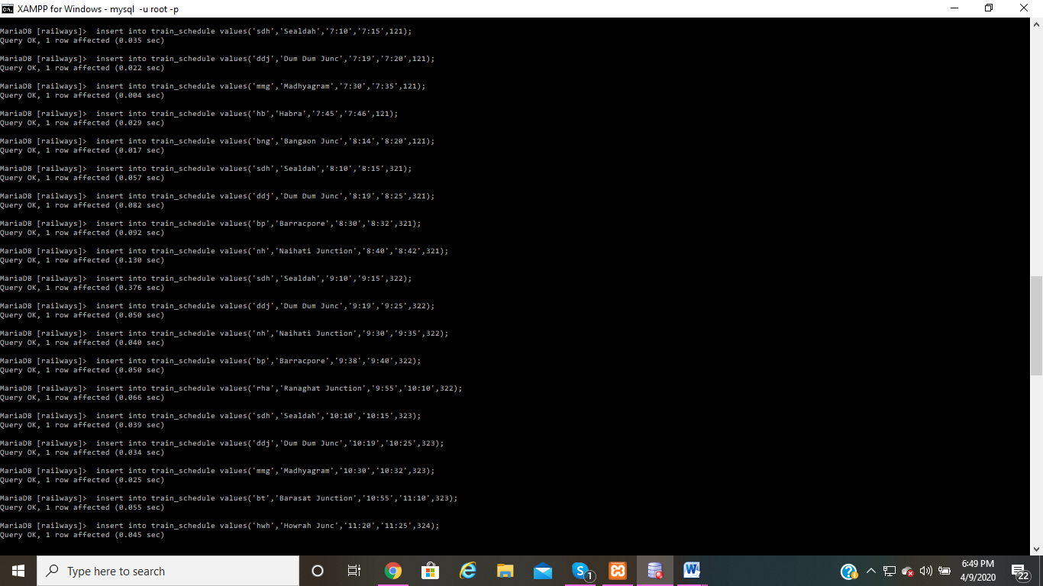

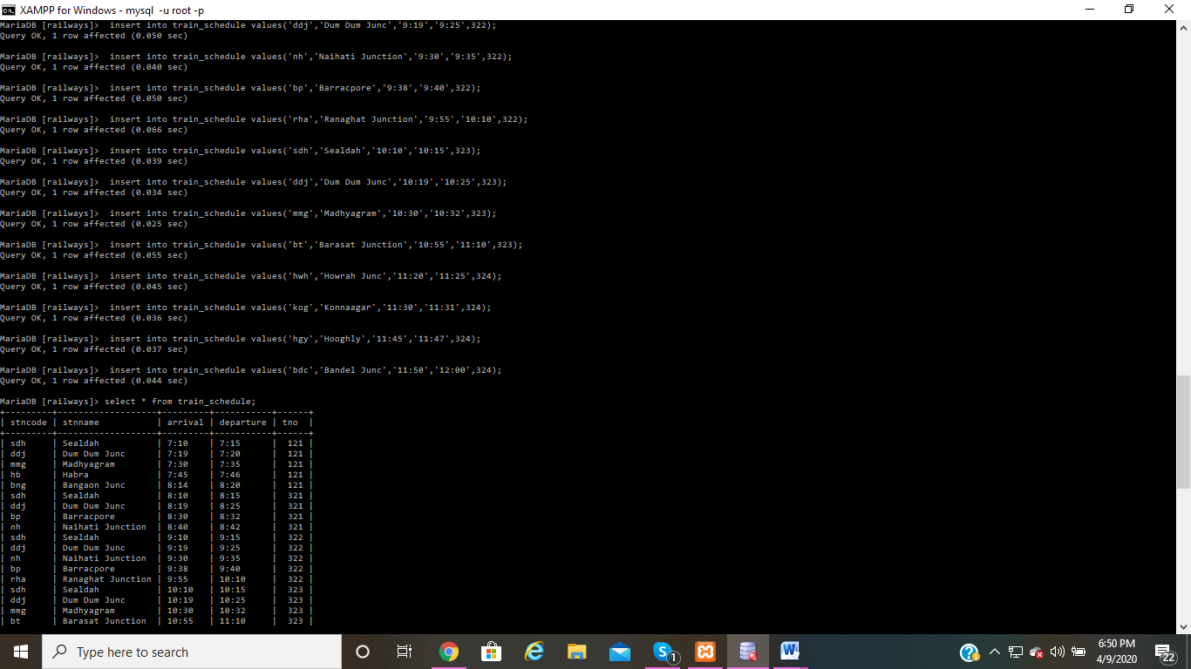

**-----VIEWING THE DETAILS OF TABLE TRAIN_SCHEDULE--------**

MariaDB [railways]> select * from train_schedule;

+---------+-------------------+---------+-----------+------+

| stncode | stnname | arrival | departure | tno |

+---------+-------------------+---------+-----------+------+

| sdh | Sealdah | 7:10 | 7:15 | 121 |

| ddj | Dum Dum Junc | 7:19 | 7:20 | 121 |

| mmg | Madhyagram | 7:30 | 7:35 | 121 |

| hb | Habra | 7:45 | 7:46 | 121 |

| bng | Bangaon Junc | 8:14 | 8:20 | 121 |

| sdh | Sealdah | 8:10 | 8:15 | 321 |

| ddj | Dum Dum Junc | 8:19 | 8:25 | 321 |

| bp | Barracpore | 8:30 | 8:32 | 321 |

| nh | Naihati Junction | 8:40 | 8:42 | 321 |

| sdh | Sealdah | 9:10 | 9:15 | 322 |

| ddj | Dum Dum Junc | 9:19 | 9:25 | 322 |

| nh | Naihati Junction | 9:30 | 9:35 | 322 |

| bp | Barracpore | 9:38 | 9:40 | 322 |

| rha | Ranaghat Junction | 9:55 | 10:10 | 322 |

| sdh | Sealdah | 10:10 | 10:15 | 323 |

| ddj | Dum Dum Junc | 10:19 | 10:25 | 323 |

| mmg | Madhyagram | 10:30 | 10:32 | 323 |

| bt | Barasat Junction | 10:55 | 11:10 | 323 |

| hwh | Howrah Junc | 11:20 | 11:25 | 324 |

| kog | Konnaagar | 11:30 | 11:31 | 324 |

| hgy | Hooghly | 11:45 | 11:47 | 324 |

| bdc | Bandel Junc | 11:50 | 12:00 | 324 |

+---------+-------------------+---------+-----------+------+

22 rows in set (0.001 sec)

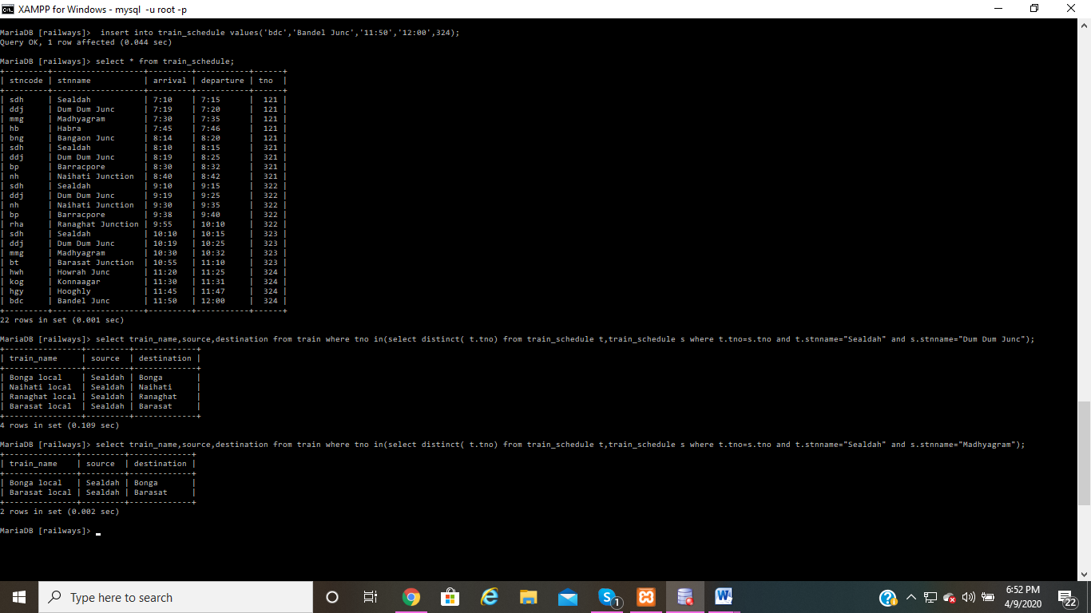

**--GETTING THE NAMES OF THE TRAINS WHICH RUN BETWEEN TWO STATIONS---**

MariaDB [railways]> select train_name,source,destination from train where tno in(select distinct( t.tno) from train_schedule t,train_schedule s where t.tno=s.tno and t.stnname="Sealdah" and s.stnname="Dum Dum Junc");

+----------------+---------+-------------+

| train_name | source | destination |

+----------------+---------+-------------+

| Bonga local | Sealdah | Bonga |

| Naihati local | Sealdah | Naihati |

| Ranaghat local | Sealdah | Ranaghat |

| Barasat local | Sealdah | Barasat |

+----------------+---------+-------------+

4 rows in set (0.109 sec)

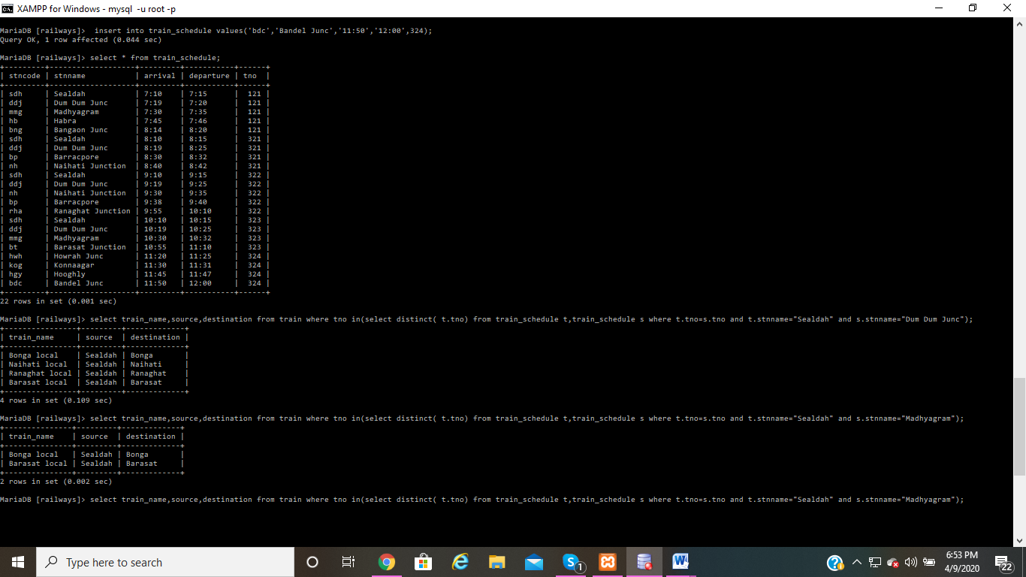

MariaDB [railways]> select train_name,source,destination from train where tno in(select distinct( t.tno) from train_schedule t,train_schedule s where t.tno=s.tno and t.stnname="Sealdah" and s.stnname="Madhyagram");

+---------------+---------+-------------+

| train_name | source | destination |

+---------------+---------+-------------+

| Bonga local | Sealdah | Bonga |

| Barasat local | Sealdah | Barasat |

+---------------+---------+-------------+

2 rows in set (0.002 sec)



MariaDB [railways]>